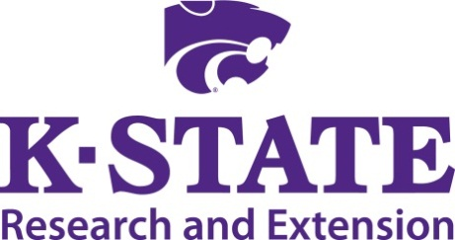

Animal Science Extension Agent Update
Eastern Kansas

November 18, 2014

Lyon County Fairgrounds
Contact:
Joel DeRouchey Jaymelynn Farney
jderouch@ksu.edu jkj@ksu.edu

9:00 Coffee/donuts

9:30 Welcome and introductions …….. Joel DeRouchey and Jaymelynn Farney

9:45 ASI department update Joel DeRouchey

10:00 Dairy industry update Mike Brouk

10:30 Meats Extension programming Travis O’Quinn

11:00 Refreshment break All

11:15 Youth livestock program update Hilary Hawkins

11:45 Swine industry update Mike Tokach

12:15 Lunch …………………………………..………………....Provided on-site

12:45 Equine Resources ……….………………Jason Turner, New Mexico State

1:15 BRANDS beef formulation program update……………Jaymelynn Farney

1:45 SE Livestock Research Program.......... Lyle Lomas and Jaymelynn Farney

2:15 Changes in feed antibiotic use for livestock Brian Lubbers, KSU Vet Med

2:45 Closing Thoughts ………………..…Everyone

