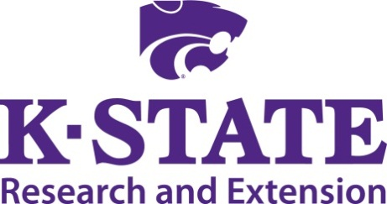

Animal Science Extension Agent Update
Western KS Edition

November 12, 2014 November 13, 2014

Front Door Community Center Basement Conference Room
1615 Tenth St. Holy Cross Lutheran Church
Great Bend, KS 1102 Court Street
Scott City, KS

Please RSVP by Friday Nov. 7th

Contact:
Sandy Johnson Justin Waggoner
sandyj@ksu.edu jwaggon@ksu.edu

9:30 Registration and Socialization

10:00 Welcome and introductions …….. Sandy Johnson and Justin Waggoner

10:15 ASI department update Ken Odde

10:45 Meats Extension programming Travis O’Quinn

11:15 Swine Industry update Mike Tokach/Joel DeRouchey

11:45 Dairy employee training and development Luis Mendonca

12:15 Lunch …………………………………..………………....Provided on-site

1:00 Equine Extension Resources ……….………………Jason Turner, New Mexico State

1:45 Wildlife policy update…………… Charlie Lee

2:15 Sheep and meat goat industry update.......... Brian Faris

2:45 Livestock Programming Discussion Everyone

Adjourn

