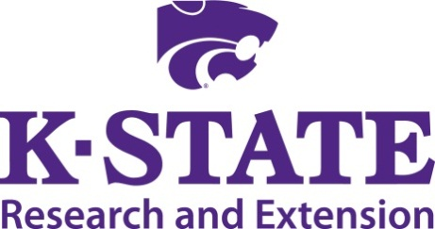

Animal Science Extension Agent Update
Eastern Kansas

November 10, 2015

Lebo City Library
327 S Ogden St, Lebo, KS 66856

Contact:
Joel DeRouchey Jaymelynn Farney
jderouch@ksu.edu jkj@ksu.edu

9:00 Coffee/donuts

9:30 Welcome and introductions …….. Joel DeRouchey and Jaymelynn Farney

9:45 ASI Department Update Joel DeRouchey

10:00 Youth Livestock Program Update Lexie Hayes

10:30 Meats Extension Program Update Travis O’Quinn

11:00 Refreshment break All

11:15 Wildlife Charlie Lee

11:45 Bermuda Grass project Keith Martin

12:15 Lunch …………………………………..………………....Provided on-site

12:45 The expanding world of bull EPD’s, indexes, ratio’s, etc… …Bob Weaber

1:15 AI vs natural bull breeding, current costs………….………Sandy Johnson

1:45 Weather impact on summer forage quality and cattle gains ....... Dale Blasi

2:15 Reinforcing the value of cattle implants for producers Chris Reinhardt

2:45 Closing Thoughts ………………..…Everyone

