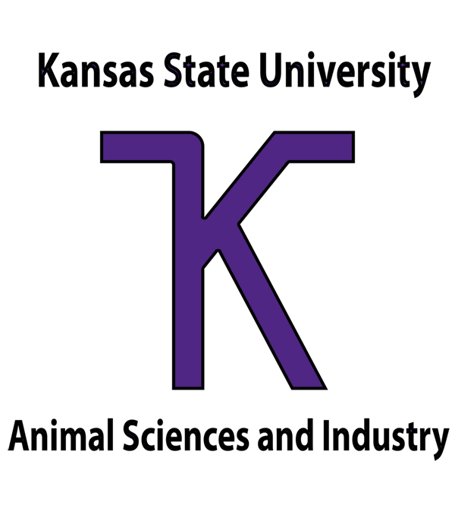

FOR IMMEDIATE RELEASE
Contact: Sharon Breiner, Director, Kansas State University Animal Sciences Leadership Academy at sbreiner@ksu.edu or 785-532-1267

July 1, 2021

High School Students learn to Lead the Animal Science Industry
Students from across the country participated in an immersive livestock and leadership learning experience at Kansas State University.
MANHATTAN, Kan. – Eleven students from four states gathered on the Kansas State University campus and online to gain livestock industry knowledge and develop leadership skills. The K-State Animal Science Leadership Academy offered a hybrid academy, June 15-18. The hybrid format included virtual instruction, followed by a closing, one-day, in-person experience on campus.
Hosted by the K-State Department of Animal Sciences and Industry and sponsored by the Livestock and Meat Industry Council, Inc the academy’s goal is to develop young leaders within the livestock industry and prepare them for a successful future in this field.
This year’s class included: Emma Aufdemberge, Leavenworth; Jodee Borgerding, Marysville; Brynn Collier, Mound City; Lucie Dolenc, Boulder, Colo.; Helaina Fowler, Lewistown, Mont.; Lane Fritz, Gypsum; Ashtyn Jolly, Lancaster; Kyanna Lankton, LeRoy; Logan Ohlde, Winchester; Calley Stubbs, Wallace; and Lauren Thompson, Woodville, Wis.
During their time at KASLA, students participated in interactive leadership development and educational sessions led by faculty members from across the K-State campus. “I not only learned about the vast Kansas agriculture industry. I learned my leadership strengths and how I can best use them to advocate for the industry in the future,” said Lauren Thompson. “I now have a potential toolbox full of career paths and a network of industry professionals to help me make decisions about my future along the way. Wonderful mentors, speakers, and members of the K-State faculty, and current K-State students made my time at KASLA a very positive and educational experience.”
KASLA also included two days of virtual livestock industry tours with hosts including: Hildebrand Farms Dairy, Junction City; Kansas Livestock Association, Topeka; Bichelmeyer Meats, Kansas City; Gardiner Angus Ranch, Ashland; and Blythe Family Farms, White City. They also enjoyed tours of university farms, ASI department facilities and the K-State campus. Evening activities included game night and a virtual escape room to help students get to know each other and use their problem-solving skills.
You can find out more information about the academy and future programs by visiting the K-State Youth Livestock Program website, asi.ksu.edu/youthlivestock. For questions, contact academy director Sharon Breiner at sbreiner@ksu.edu or 785-532-1267.
-30-

Cutline:
K-State Animal Sciences Leadership Academy (KASLA) attendees June 5-8 in Manhattan, Kansas, (front row, l to r) are: Brynn Collier, Mound City; Lauren Thompson, Woodville, Wis.; Kyanna Lankton, LeRoy; Lane Fritz, Gypsum; Helaina Fowler, Lewistown, Mont.; Ashtyn Jolly, Lancaster; and Sharon Breiner, staff. Back row (l to r) are: Lucie Dolenc, Boulder, Colo.; Logan Ohlde, Winchester; Emma Aufdemberge, Leavenworth; Calley Stubbs, Wallace; Jodee Borgerding, Marysville; Ashley Hartman, staff; and Dr. Mike Day, KSU ASI Department Head.

###

The Kansas State University Department of Animal Sciences and Industry serves students, livestock producers and the animal and food industries through teaching, research and education. The K-State ASI department prepares students for careers in the animal and food industries. The curriculum includes the study of nutrition, reproduction, genetics, behavior, meat science and food science with production, management, and agribusiness skills. For more about the K-State’s ASI department visit asi.ksu.edu.

The Livestock and Meat Industry Council is dedicated to facilitating interdisciplinary research that identifies and addresses issues/opportunities facing animal agriculture and the efficient production of food. The Council solicits volunteer contributions including money, land, livestock, equipment and other bequests in support of approved priorities and initiatives within the Department of Animal Sciences and Industry, in cooperation with the College of Agriculture at K-State.

