Applicants: Please word process your application 2022
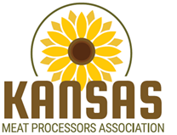

2022 KMPA Meat Science Scholarship Application Form

Name___________________________________________ Email ____________________

Home address____________________________________ Phone____________________

Manhattan address________________________________ Phone____________________

Major and option__________________________________ Advisor___________________

Expected graduation date___________________

KSU credit hrs____________ KSU GPA__________

Trans. College_____________________________ Credit hrs__________ GPA__________

Note: At time of application, applicant must have completed 30 hours of KSU and/or transfer credits
and have at least two semesters remaining at KSU.

Please attach separate pages for:
- Copy of your resume

- Brief description of your background, interests, and possible career choices related to the meat industry (about 1 page, 2 maximum)

Evaluation Breakdown:
Meat science interest and activities 30%
Interview 25%
GPA 25%
Resume 20%

Return completed application to any KSU Meat Science Faculty by Friday, April 15, 2022

