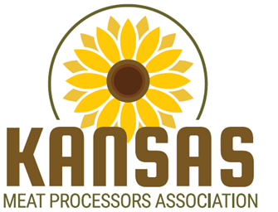
Meat Science Scholarships

TYPE: Undergraduate Meat Science Scholarships
(Two $1,000 Scholarships will be awarded)

DONOR: Kansas Meat Processors Association
The Kansas Meat Processors Association (KMPA) is a trade association of small to medium-size independent meat businesses and their suppliers. Business is conducted by elected officers and a Board of Directors. Problems of the industry are identified and positions on issues related to their businesses are communicated to governmental agencies or elected officials. Major activities sponsored or co-sponsored by KMPA include: 1) the annual convention with a processed product competition and trade show; 2) the Midwest Meat Processors Workshop at Kansas State University; 3) annual legislative receptions; 4) interaction with other agricultural trade associations; and 5) student scholarships in Meat Science at KSU.

ELIGIBILITY:
Must be currently enrolled at Kansas State University and have completed at least 30 (KSU plus transfer) credit hours but no more than 95 total collegiate credit hours. Preference will be given to Animal or Food Science undergraduate majors with a strong interest in the meat industry. Selection criteria: demonstrated interest in the meat science field, activities, a personal interview, grade point average, and need.

APPLICATION INFORMATION:
Forms are available from the Meat Science Faculty (Drs. Boyle, O’Quinn, Chao, Vipham, and Zumbaugh), Weber Hall, or download at:
http://www.asi.k-state.edu/research-and-extension/meat-science/scholarships/

APPLICATION:
Return forms to any Meat Science Faculty Member by April 15, 2022.

FINALIST INTERVIEWS:
Finalists will be personally interviewed by members of the Scholarship Selection Committee

RECIPIENT REQUIREMENTS:
- Must be enrolled at KSU the semester scholarship is awarded.

